LINKS DE FÍSICA.

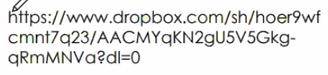

https://chat.whatsapp.com/CpO5BmdMIfsIbFEzqihfzi

https://www.dropbox.com/sh/hoer9wfcmnt7q23/AACMYqKN2gU5V5Gkg-qRmMNVa?dl=0